**EXP NO 8** Create a simple cloud software application for Students Attendance System using any Cloud Service Provider to demonstrate SaaS include the necessary fields such as name of the students, course, present , Absent, course attendance, OD request, grade, attendance percentage, etc.

**AIM:**

TO create a simple cloud software application for online student attendance system using any cloud service provider to demonstrate saas.

**PROCEDURE:**

**STEP1:** GOTO ZOHO.COM STEP

**STEP2:** LOGIN TO THE ZOHO.COM STEP

**STEP 3**: SELECT ONE APPLICATION STEP

**STEP 4:** ENTER APPLICATION NAME STEP

**STEP 5:** CREATED NEW APPLICATION STEP

**STEP 6:** SELECT ONE FORM STEP

**STEP 7:** THE SOFTWARE HASE BEEN CREATE

**PROCEDURE**

**STEP 1** GO TO ZOHO.COM

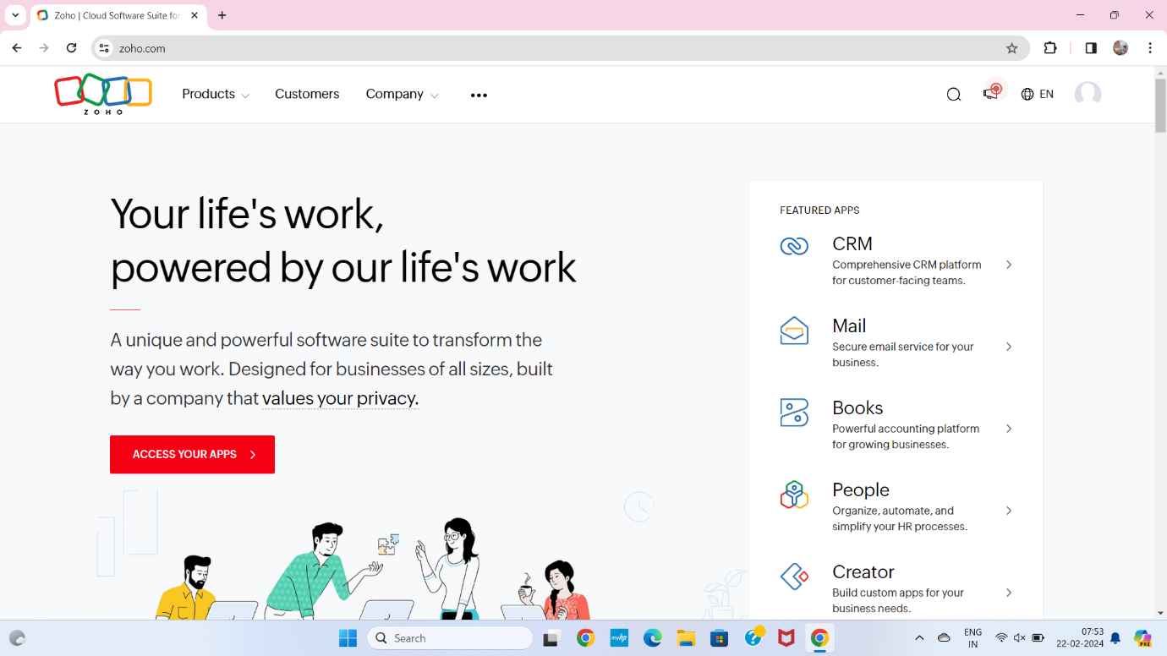

**STEP2** LOGIN TO THE ZOHO.COM

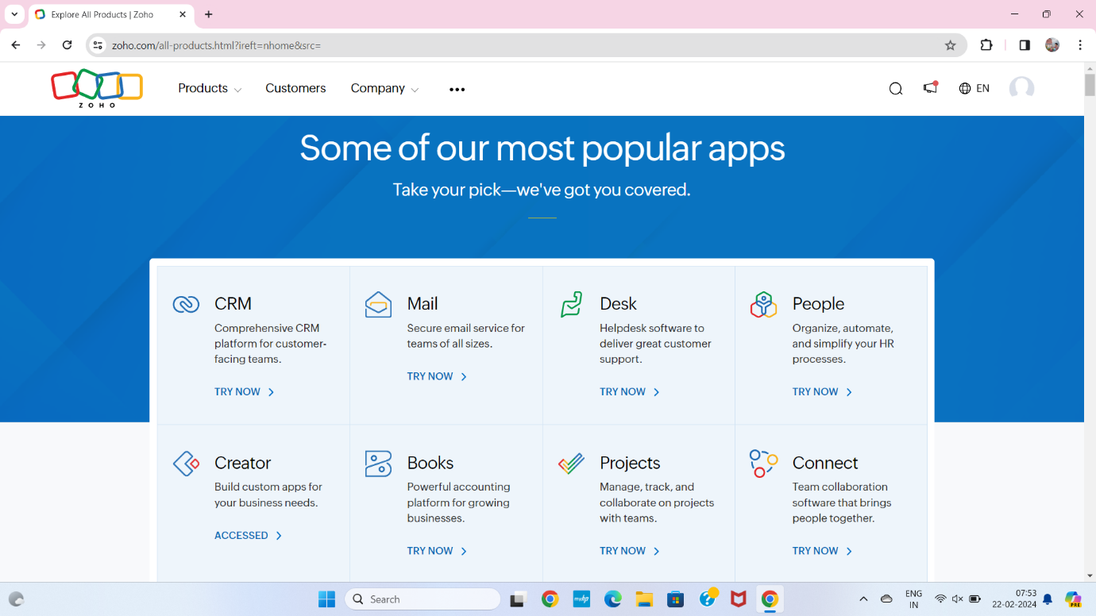

**STEP 3** SELECT A CREATE FROM SCRATCH

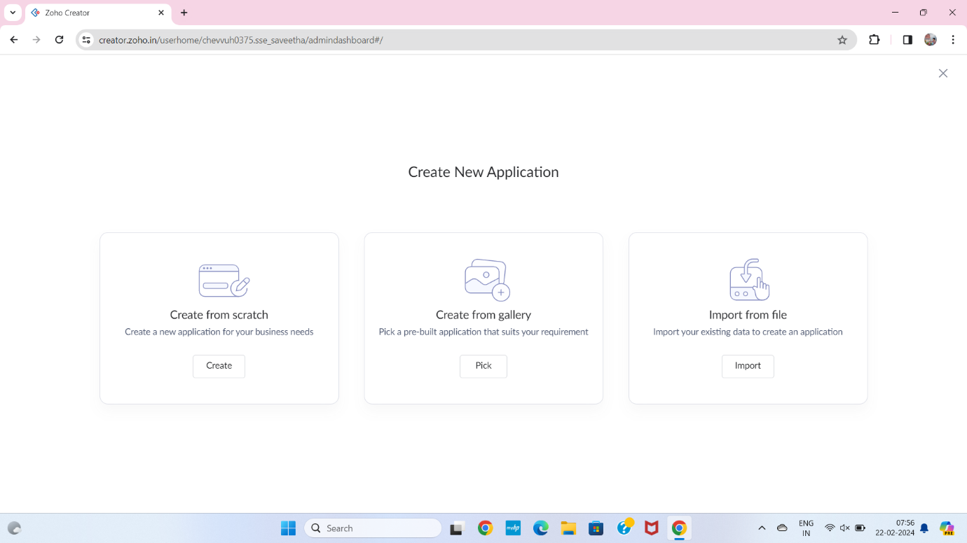

**STEP 4** SELECT APPLICATION NAME AS PROPERTY STUDENT ATTENDANCE SYSTEM

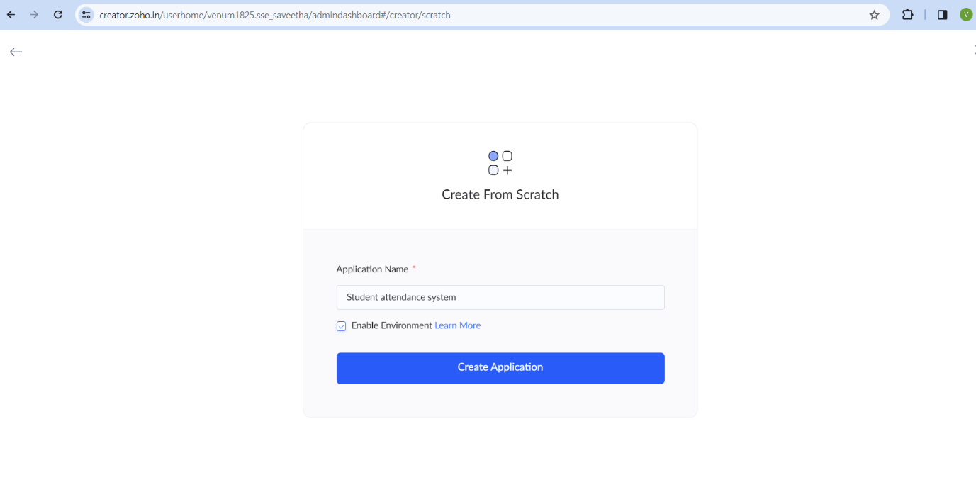

**STEP 5** CREATE A NEW FORM

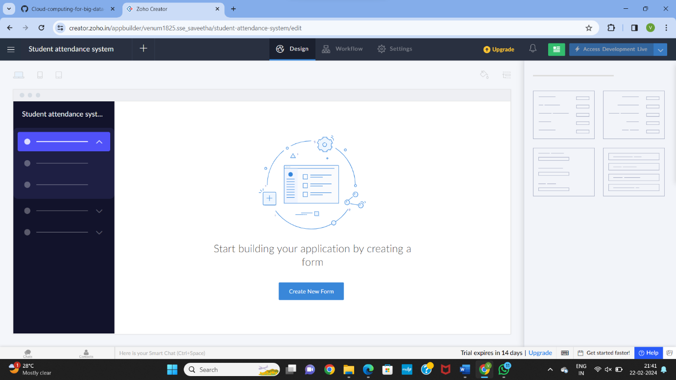

**STEP 6** SELECT BASIC FIELD FROM GIVEN BELOW AND DEVELOP APPLICATION

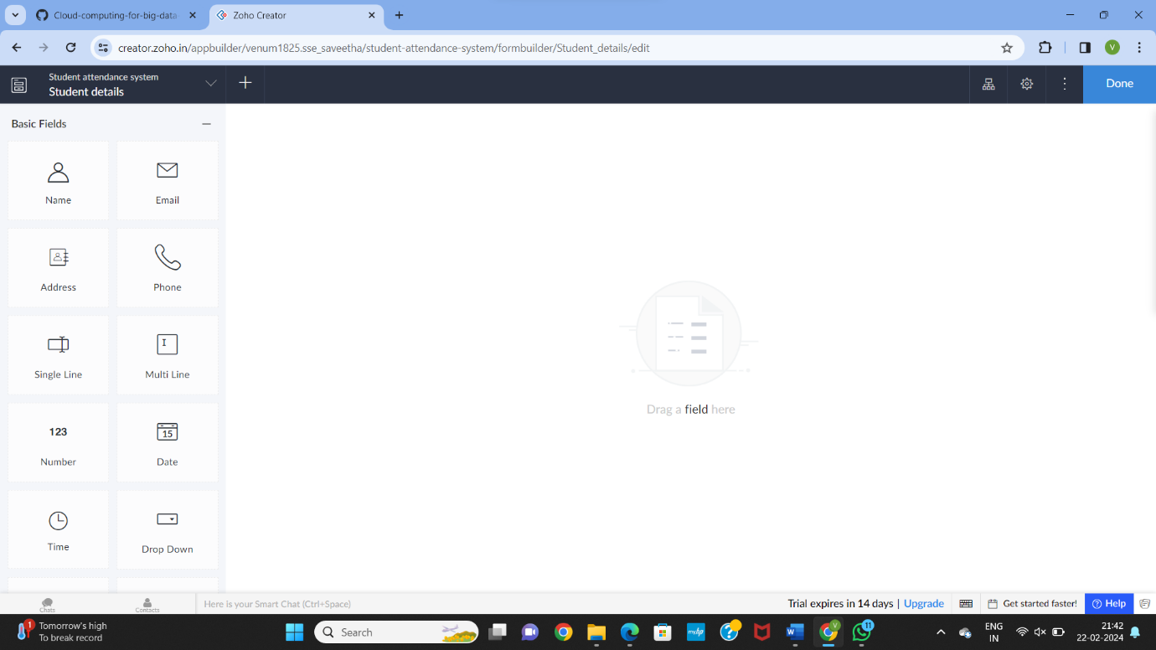

**STEP 7** THE SOFTWARE HASE BEEN CREATED STUDENT DETAILS

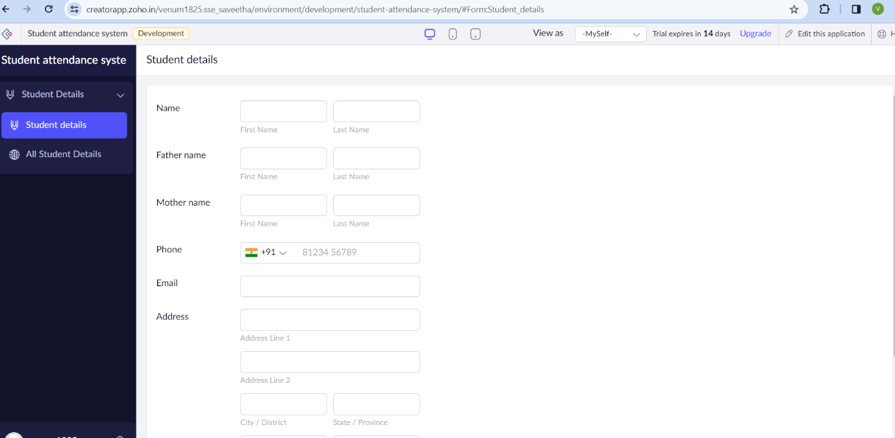

**STEP 8** THE SOFTWARE HASE BEEN CREATED COURSE ATTENDANCE

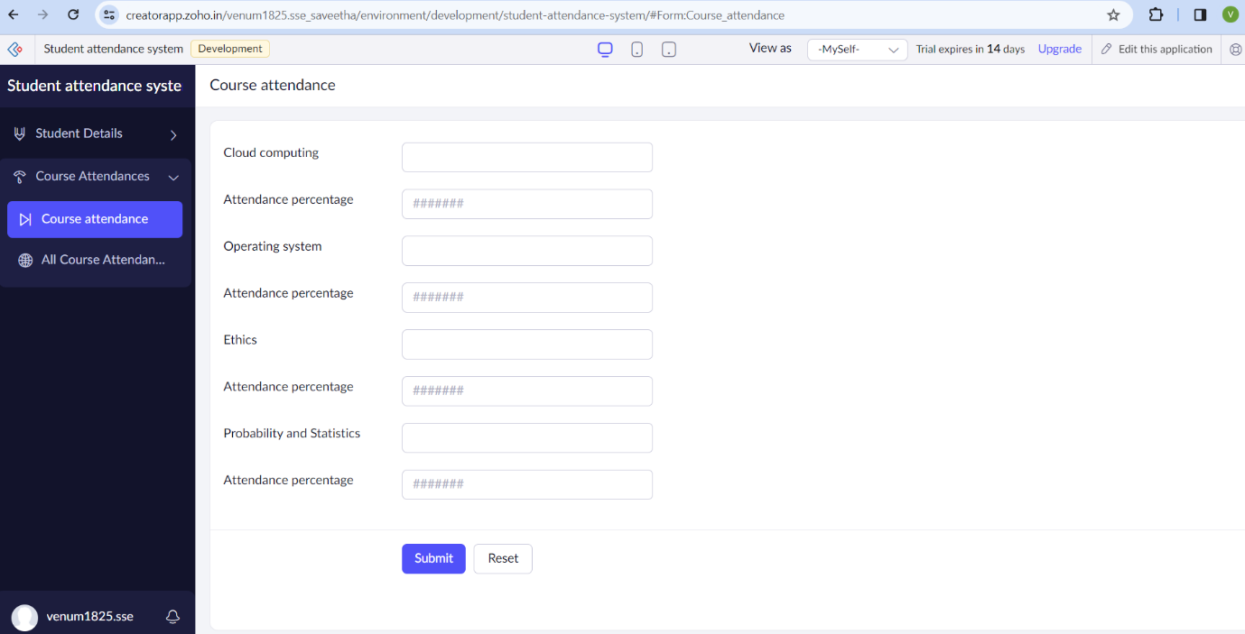

**STEP 9** THE SOFTWARE HASE BEEN CREATED ABSENT REASON

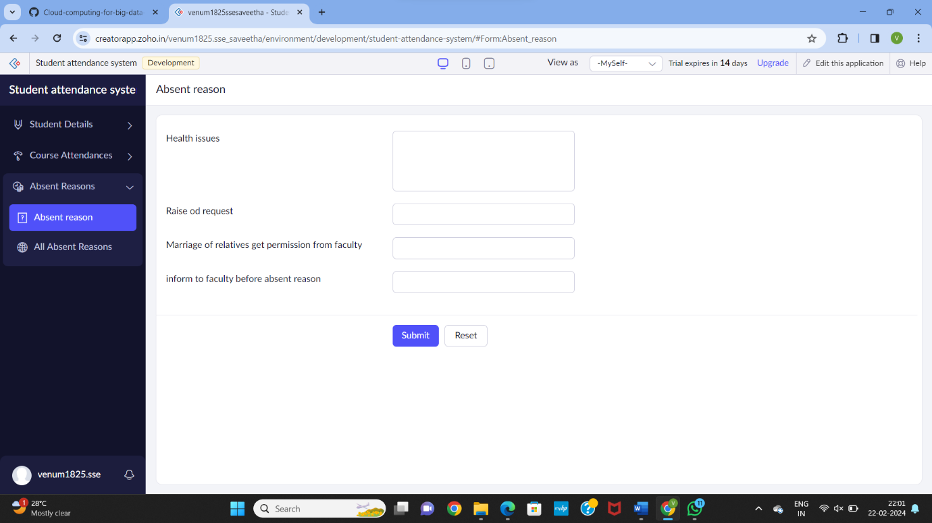

**STEP 10** THE SOFTWARE HASE BEEN CREATED PAYMENT

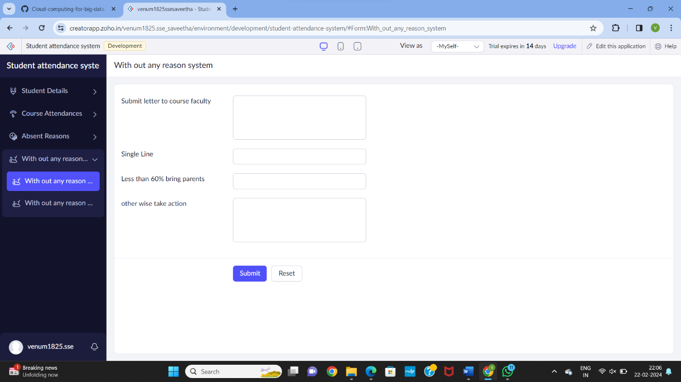

**STEP 12** THE SOFTWARE HASE BEEN CREATED

